Matthew Marinelli

SNHU CS 340

Project 2 Module 6

Project 2 Module 7 CS 340: MONGO DB



The image shows a way that we can filter data. For example, when a specific user clicks a specified button, the data on the table displays the animals that were selected by the user in that category.

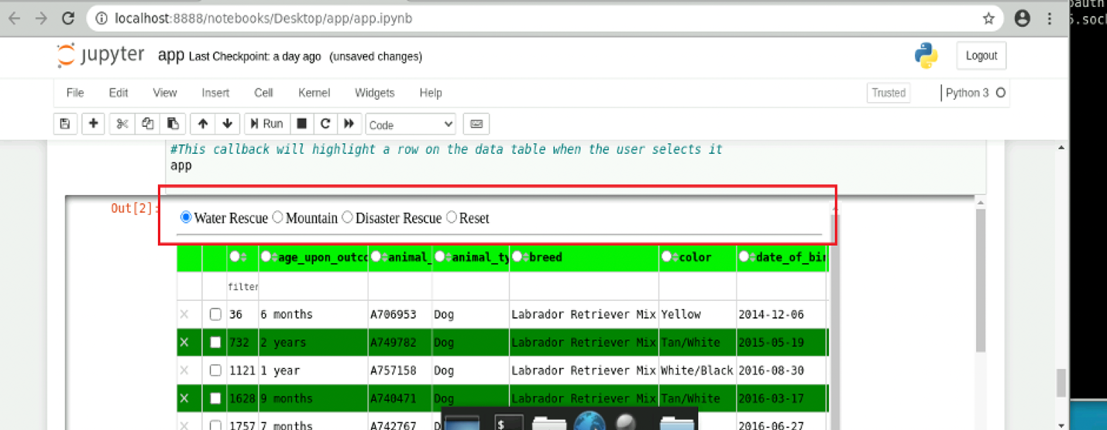

Here are the other charts that display data for the animals the user selected.

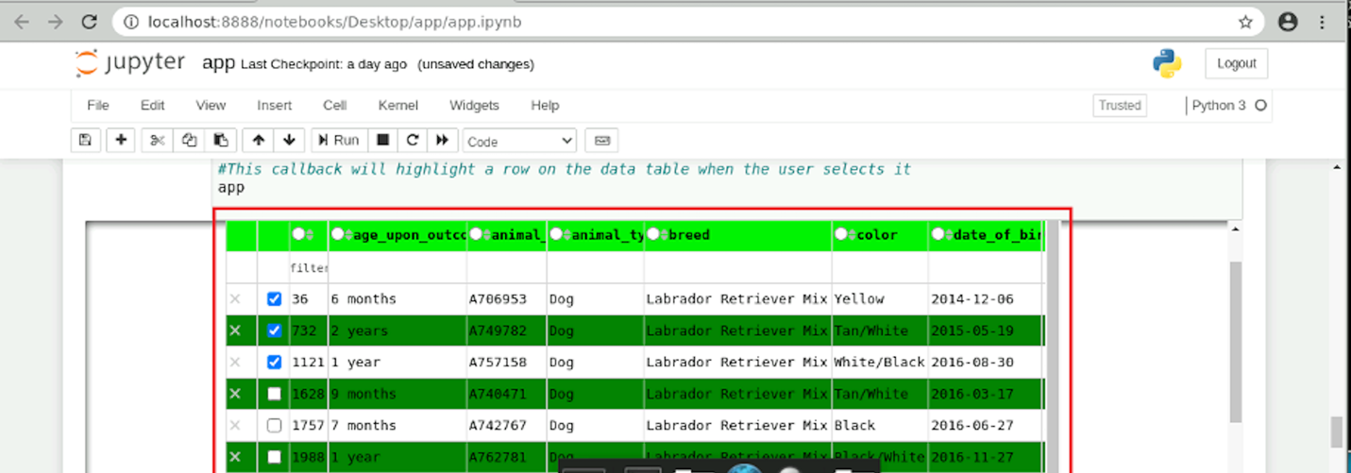

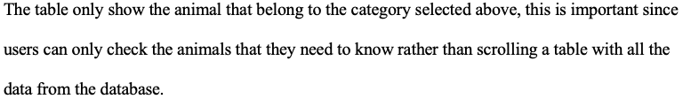

The below image is a chart that shows the approximate GPS location of the company as well as some small metadata about the actual animal itself. The map also gives a direction similar to Apple or Google maps as well.

